DEPARTMENT OF BASIC SCIENCES AND ISLAMIAT
University of Engineering and Technology, Peshawar

PAPER: Linear Algebra (BSI-111)
Mid -Term Examination 3rd semester Fall-2020
( Computer system Engineering)
Time Allowed: 2 hours Max Marks: 20

Note: Attempt all questions:
Q1. CLO-1, Cognitive Domain, PLO-2, Taxonomy Level-2
- An oil refinery produces low-sulfur and high-sulfur fuel. Each ton of low- sulfur requires 5 minutes in the blending plant and 4 minutes in the refining plant, each ton of high-sulfur fuel requires 4 minutes in the blending plant and 2 minutes in the in the refining plant. If the blending plant is available for 3 hours and the refining plant is available for 2 hours how many tons of each type of fuel should be manufactured so that the plants are fully utilized?
b Let 0 represent OFF and 1 represent ON and 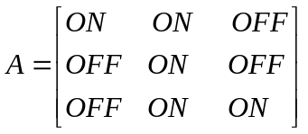
Find the ON/OFF matrix B so that A + B is a matrix with each entry ON.
Q2 . CLO-1, Cognitive Domain, PLO-2, Taxonomy Level-2
a) Let be 3- vector denoting the current prices of three items at stores A & B, respectively.
- Obtain a 2 x 3 matrix representing the combined information about the prices of the three items at the two stores.
- Suppose that each store announces a sale so that the price of each items is reduced by 20% obtain a 2 x 3 matrix representing the sale prices at the two stores.
b) Construct a linear system of equations to determine a quadratic polynomial 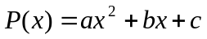 that satisfies the conditions
Q3. CLO-2, Cognitive Domain, PLO-1, 2 Taxonomy Level-3

a) Find an LU-factorization of the of the co-efficient matrix of the given linear system Ax = b. solve the linear system using a forward substitution followed by a back substitution.
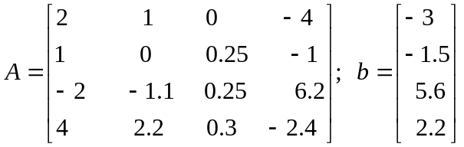
b) The matrix transformation 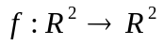defined by 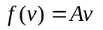where
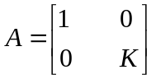
Where K is a real number is called dilation in the y- direction 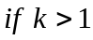 and contraction in the y- direction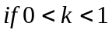. If R is the unit square and f is the contraction in the y-direction with 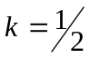 , find and sketch the image of R.
Q4. CLO-2, Cognitive Domain, PLO-1, 2 Taxonomy Level-3
a) A study has determined that the occupation of a boy as an adult, depends upon the occupation of his father and is given by the following transition matrix, where P = professional, F = farmer, and L = laborer

Father’s occupation
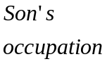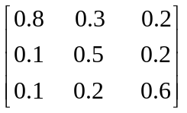
Thus the probability that son of a professional will also be a professional is 0.8 and so on.
- What is probability that the grandchild of a professional will also be a professional?
- In the long run, what proportions of the population will formers?
b) A ship is being pushed by a tugboat with force of 300 pounds along the negative y-axis while another tugboat is pushing along the negative x-axis with the force of 400 pounds. Find the magnitude and sketch the direction of the resultant speed?

